Case Study – Hindustan Zinc Limited (HZL) – Mining Operations in Rajasthan, India
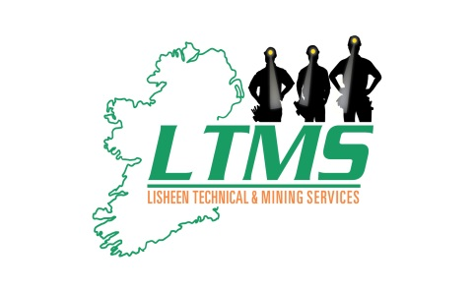

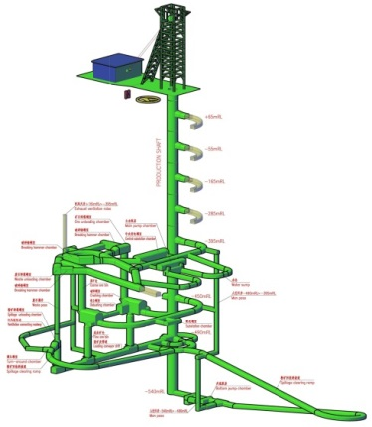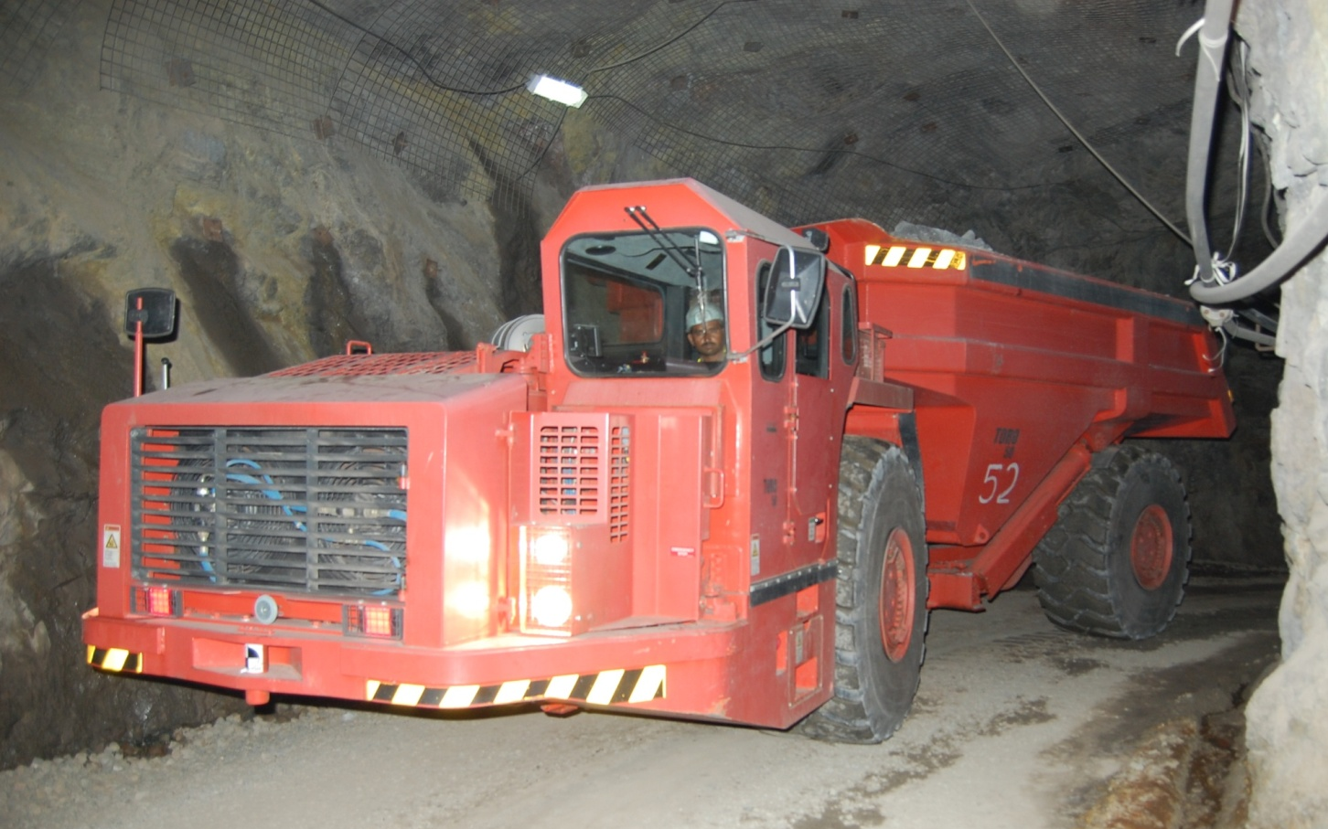

Project | Hindustan Zinc Limited – Master Trainer Programme
Date | Period: August 2016 – Ongoing
Location | Udaipur, Rajasthan, India
Client | Hindustan Zinc Limited, India has 9 mining operations, producing more than 800,000 tonnes of zinc per annum, with a significant growth rate. HZL are in the process of bringing all of their operations to a world class standard. HZL are owned primarily by Vedanta Resources, the owners of the Lisheen mine (now closed) in Tipperary. HZL is the 3rd largest zinc producer in the world, with all 9 operating mines and pits, located in Rajasthan, India.
Services offered by LTMS Limited | Mining Operations Training & Mine Rehabilitation  Geotechnical Engineering, Geology & Mine Planning  Drill and Blast Design and Management  Maintenance Services, Safety Training and Management
Project Objectives/ Outcomes | The main objective of the Master Trainer Programme is to provide a training programme for selected mining operators and train them to a level where they have the skill levels to train local operators.
Our Role | The LTMS objective is as follows:  - Select the best operators on drill jumbos, LHD machines and production drill rigs, who also have the aptitude to become trainers  - Train the select group to a world class standard on the operation of their specific machine type  - Train the select group in all safe standard operating procedures  - Train the group in methods of training and methods of assessment of trainees  - Monitor and evaluate the trainers, when training local operators
LTMS Personnel | Five LTMS trainers are engaged in this programme for a period of up to one year.  The Trainers are all former Lisheen Mine personnel, who are specialist on the mining equipment. The trainers are all either qualified supervisors or mining engineers.

